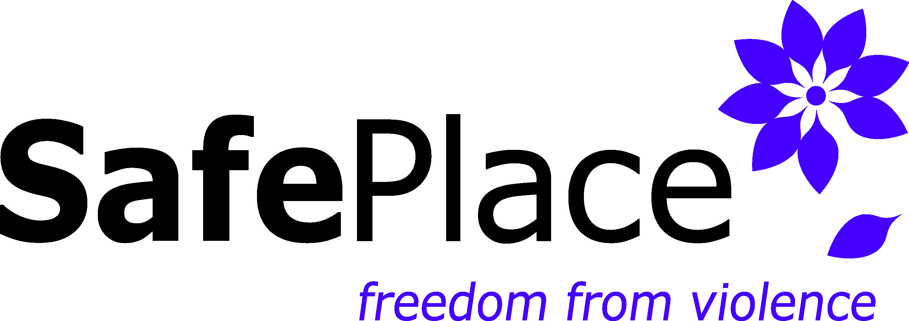
Job Title: Support Services Volunteer for the Community Service Center
Reports to: Volunteer Program Manager & Administrative Assistant or Development staff
Hours Per Week: 4 hours per week, or otherwise specified

SafePlace, Thurston County's designated sexual and domestic violence services agency, has an opening for a full-time Communications and Grants Officer. We are an accredited, nationally recognized feminist organization committed to anti-oppression efforts as the foundation for management and services. More about SafePlace can be found at www.safeplaceolympia.org.
Support Services Volunteers for Community Service Center will, in a culturally responsive manner, assist the Administrative Assistant and Development Team with administrative and office tasks such as, but not limited to, desk coverage, filing, and mailings.

ESSENTIAL DUTIES AND RESPONSIBILITIES
The Essential Duties and Responsibilities of this position include the following. Other duties may be assigned.

Administrative
- Assist with answering the phone, filing, desk coverage, restock toiletries supplies and snacks in lobby as needed, and other office tasks at the Community Service Center front desk
- Maintain a clean and comfortable lobby area for clients
- Collaborate with staff to assist in data entry
- Assist in organization of donations as needed

Development
- Participate in large-scale mailings, and other such tasks
- Participate in set up, break down and general assistance during development events

MINIMUM QUALIFICATIONS
- Willing to participate in the first 3 ACT Trainings
- Ability to work independently and within a team structure
- Excellent communication skills, written and other
- Ability to work under pressure
- Ability to handle detailed work accurately
- Excellent organizational skills; experience managing several projects at the same time
- Ability to use the internet
- Ability to answer a multi-line phone
- Agreement with the SafePlace philosophy and the theory of empowerment
- Commitment to the need for client and agency confidentiality

PREFERRED QUALIFICATIONS
- Demonstrated understanding of domestic and sexual violence issues
- Experience working with diverse populations

To apply: go to https://www.safeplaceolympia.org/volunteer/

SafePlace employment is conditioned upon agreement with the SafePlace Philosophy Statement and passing a Washington State Patrol criminal background check.

SafePlace is an equal opportunity employer. Our agency is committed to a culturally and ethnically diverse workplace.
11.19

