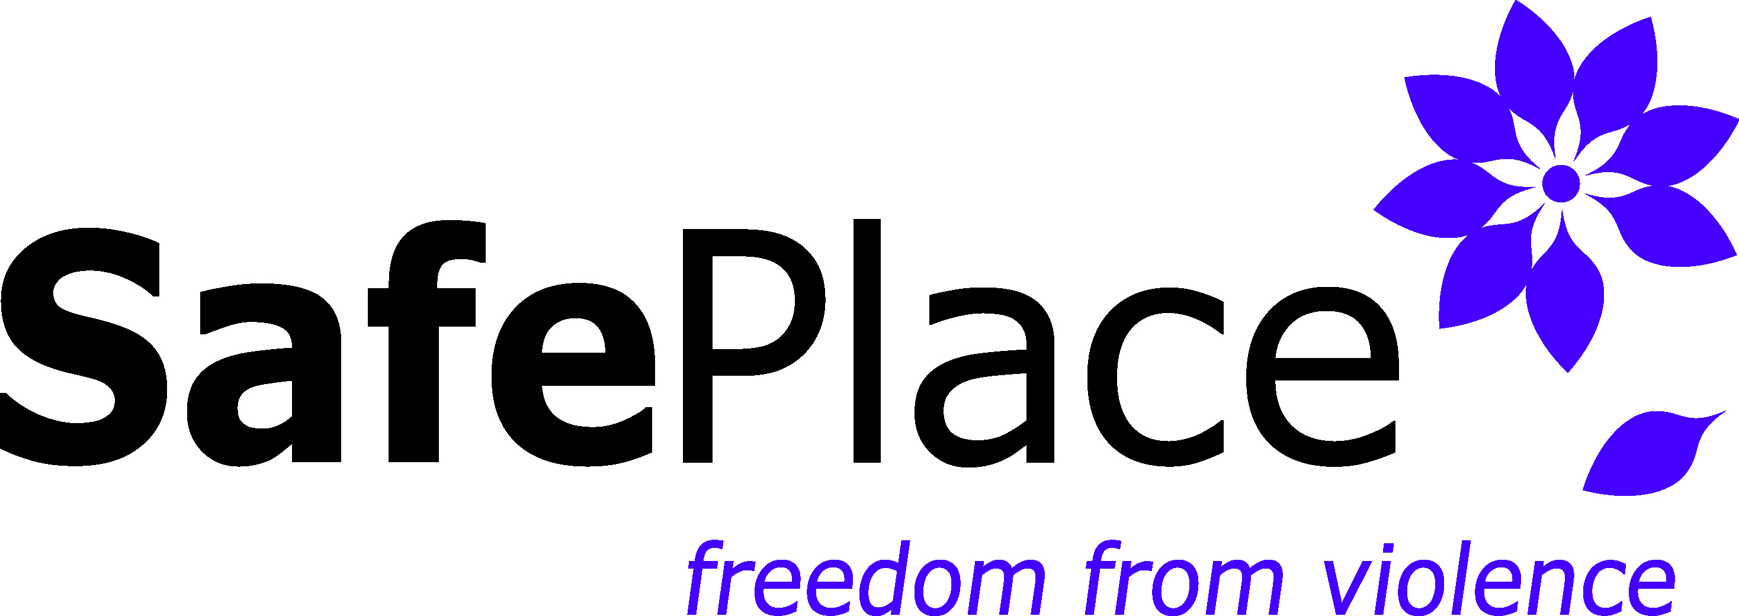

Position Title: DS Helpline Volunteer for the Community Service Center
Reports to: Volunteer Program Coordinator & Community Services Program Manager

Hours Per Week: 4 hours per week, or otherwise specified
Required Schedule Availability one of the following:
- 9am-1pm, Monday- Thursday
- 1pm-5pm, Monday- Thursday

SafePlace, Thurston County's designated sexual and domestic violence services agency, has openings for Direct Services Volunteers. We are an accredited, nationally recognized feminist organization committed to anti-oppression efforts as the foundation for management and services. More about SafePlace can be found at www.safeplaceolympia.org.
Direct Services Volunteers for Community Service Center will, in a culturally responsive manner, provide advocacy in person and over the phone to our clients.

ESSENTIAL DUTIES AND RESPONSIBILITIES
The Essential Duties and Responsibilities of this position include the following. Other duties may be assigned.

Helpline Advocacy
- Answer our helpline, providing support and services to our clients over the phone
- Coordinate and provide clients with resources and information over the phone
- Will safety plan and provide referrals for clients over the phone
- Ability and willingness to abide by SafePlace’s confidentiality policy and inform clients of their rights during each client interaction
- Provide culturally relevant services

Volunteer Meetings
- Attend volunteer meetings and trainings

Ongoing Training
- Will be responsible for completing the required ongoing training requirements of 12 hours of continuing Sexual Assault training and 20 hours of continuing Domestic Violence training

MINIMUM QUALIFICATIONS
- Willing to participate in full ACT Training
- Willing to be responsible for and complete any continuing training as advised by the Volunteer Program Coordinator, up to 20 hours.
- Ability to work independently and within a team structure
- Excellent communication skills, with ability to pass on pertinent information to the next helpline advocate
- Ability to work under pressure
- Ability to handle detailed work accurately
- Ability to use the internet and answer helpline calls at the SafePlace Community Service Center
- Agreement with the SafePlace philosophy and the theory of empowerment
- Commitment to the need for client and agency confidentiality

PREFERRED QUALIFICATIONS
- Demonstrated understanding of domestic and sexual violence issues
- Experience working with diverse populations

To apply: go to https://www.safeplaceolympia.org/volunteer/

SafePlace employment is conditioned upon agreement with the SafePlace Philosophy Statement and passing a Washington State Patrol criminal background check.

SafePlace is an equal opportunity employer. Our agency is committed to a culturally and ethnically diverse workplace.

